**AIML ASSIGNMENT – 1**

**Name & Roll. No.:** Akilesh Kanna P M, 2313009.

**Dataset:** 50_Startups.CSV.

**Dependent Variable:** Profit

**Independent Variable:** Marketing Spend, R&D Spend, State and Administration.

**Interpretations for Simple Linear Regression:**

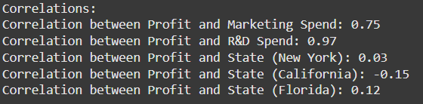

The above given is the results of correlation for the dataset, where we can infer that the relationship between Profit and Marketing Spend & R&D Spend are significant, compared to State and Administration. So, I have chosen R&D Spending and Marketing Spending to analyse further derive the model.

Considering the two variables Marketing Spend and R&D Spend, we have created a model that delivers the Simple Linear Regression results for the dataset.

**Simple Linear Regression for Profit and R&D Spend:** 0.9265108109341951

**Simple Linear Regression for Profit and Marketing Spend:** -0.11205578997827947

The above results suggest that the model between Profit and R&D Spend, this model appears to be a good fit, and then the model between the Profit and Marketing Spend, this model appears to be a poor fit.

But further analysis with Multiple Linear Regression will provide a better and more comprehensive understanding of what derives the **Profit.**

Below given are the Screenshots of the results of the Simple Linear Regression between the variables. The plots also infer the same provided above.

In the below Scatter plots, we can infer that the spread between the values for R&D Spend and Profit, fall near the line and vice versa in the case of Marketing Spend and Profit, where the values fall behind from the regression line indicating the wide spread, between the data points.

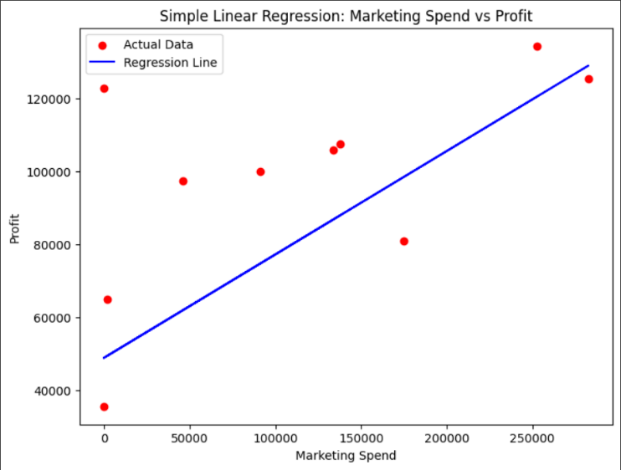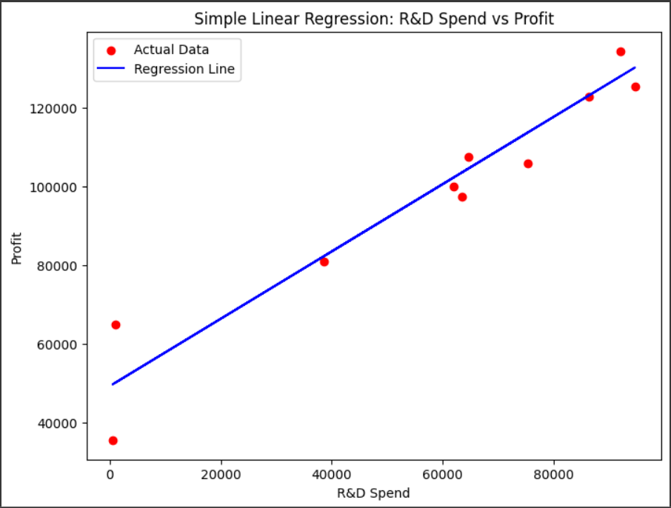

**Interpretations for Multiple Linear Regression:**

From the above results of the correlation, we have planned to conduct the Multiple Linear Regression between the Profit and R&D Spend & Marketing Spend. The results are discussed below for the Multiple Linear Regression.

**Multiple Linear Regression for Profit and R&D, Marketing Spend:** 0.9168381183550245

The above model, overall, the Multiple Linear Regression model appears to be a reasonably good fit for predicting **Profit** based on **R&D Spend and Marketing Spend.**

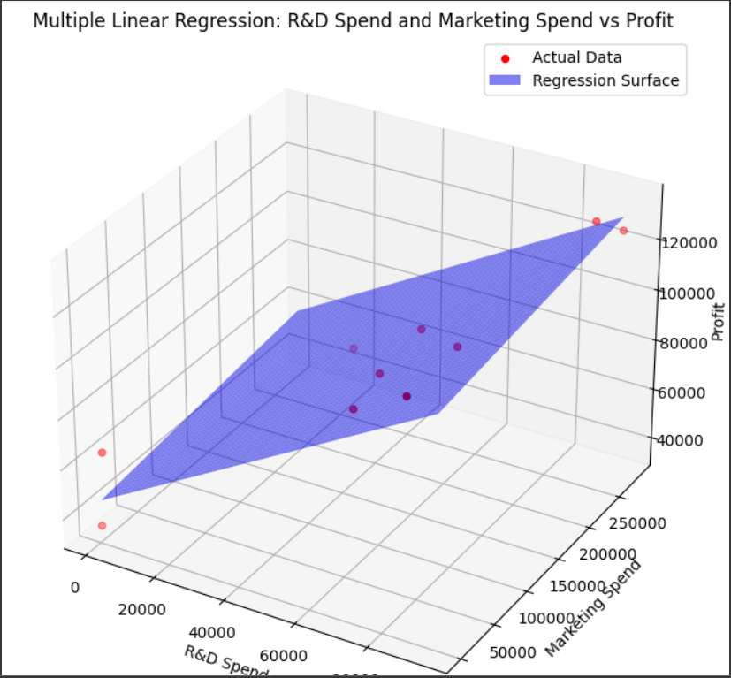

The above plot suggests that both **R&D Spend and Marketing Spend** are positively correlated with **Profit.**